**International University**

School of Electrical Engineering

**Principle of EE1 Laboratory**

**EE052IU**

**[Lab 2]**

**Kirchhoff’s Current and Voltage Laws**

**Submitted by**

[Đỗ Minh Duy - ITITSB22029]

[Nguyễn Đức Anh - EEACIU23005]

Date Submitted: [28/12/2024]

Date Performed: [18/11/2024]

Lab Section: [2]

Course Instructor: [Nguyen Minh Thien]

**GRADING GUIDELINE FOR LAB REPORT**

|  |  |  |  |  |
| --- | --- | --- | --- | --- |
| **Number** | **Content** |  | **Score** | **Comment** |
| 1 | **Format (max 9%)** | |  |  |
| * Font type | Yes No |  |
| * Font size | Yes No |  |
| * Lab title | Yes No |  |
| * Page number | Yes No |  |
| * Table of contents | Yes No |  |
| * Header/Footer | Yes No |  |
| * List of figures (if exists) | Yes No |  |
| * List of tables (if exists) | Yes No |  |
| * Lab report structure | Yes No |  |
| 2 | **English Grammar and Spelling (max 6%)** | |  |  |
| * Grammar | Yes No |  |
| * Spelling | Yes No |  |
| 3 | **Data and Result Analysis (max 85%)** | |  |  |
| **Total Score** | |  | |  |

Signature:

Date:

**Table of Contents**

List of Figures ........................................................................................….….................................3

List of Tables .................................................................................................……..........................3

Nomenclature ...........................................................................................................……………...3

Theoretical Background .............................................................................................….................4

Experimental Procedure.............................................................................................……………..5

Experimental Results .....................................................................................................................12

Discussion of Results .....................................................................................................................12

**List of Figures**

Figure 1 –………………………….……...…………………………………………………… 5

Figure 2 – …………………………………………………………………..……………...….. 6

Figure 3 – ……………………………………………………………………………………... 7

Figure 4 –………………………………………….………………………..……………...….. 8

Figure 5 – ……………………………………………………………………………………... 9

Figure 6 – ……………............................................................................................................... 9

Figure 7 – ……………............................................................................................................... 11

Figure 8 – ……………............................................................................................................... 11

**List of Tables**

Table 1 – ……………………………………..……………………........................................... 5

Table 2 – ……………………………………..……………………........................................... 5

Table 3 – ……………………………………..……………………........................................... 6

Table 4 – ……………………………………..……………………........................................... 6

Table 5 – ……………………………………..……………………........................................... 7

Table 6 – ……………………………………..……………………........................................... 7

Table 7 – ……………………………………..……………………........................................... 9

**Nomenclature**

VDD = DC Voltage Source

Vdd = AC Voltage Source

Iref = Reference Current

**Theoretical Background**

**1. The relationship of Ohm’s Law**

Ohm’s Law establishes a fundamental relationship between voltage, current, and resistance in electrical circuits. The equation V=I⋅R and V=I⋅R illustrates this relationship.

**2. The Kirchhoff’s Current Law (KCL)**

Kirchhoff’s Current Law asserts that the total current entering a junction in an electrical circuit is equal to the total current leaving the junction. This principle, expressed as :∑I_in=∑I_out, forms the basis for analyzing current distribution in complex circuits. The laboratory endeavors to experimentally verify and comprehend the application of KCL

∑Loop = 0

KVL aids in understanding voltage relationships within circuits. The objective is to experimentally confirm and grasp the implications of KVL in practical scenarios.

**3. The Kirchhoff’s Voltage Law (KVL)**

Kirchhoff’s Voltage Law posits that the total voltage around any closed loop in a circuit is equal to the sum of the individual voltage drops. Mathematically represented as

**4. The equivalent resistance**

Exploring the concept of equivalent resistance involves determining a single resistance value that represents the combined effect of resistors in a circuit. For series circuits, the equivalent resistance (Req, series) is the sum of individual resistances. In parallel circuits, the reciprocal of the equivalent resistance (,1/Req, parallel is the sum of reciprocals of individual resistances. The laboratory seeks to experimentally determine and analyze equivalent resistances in both series and parallel configurations.

**Experimental Procedure**

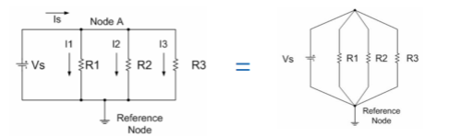

**Figure 1**

Using the adjustable D.C. power supply and circuit bread board, connect the resistors into a two-node circuit.All four circuit elements are connected between those two nodes, and the source voltage Vs is across each of the three resistors. Let R1 = 8.2 kΩ, R2 = 15 kΩ, and R3 = 39 kΩ.

**Table 1**

|  |  |  |  |
| --- | --- | --- | --- |
|  | Color | Nominal value | Actual values |
| R1 | Grey-red-red-gold | 8.2k | 8.2k |
| R2 | Brown-green-orange-gold | 15k | 14.85k |
| R3 | Orange-white-orange-gold | 39k | 38.27k |

**Table 2**

|  |  |  |  |
| --- | --- | --- | --- |
| Value | Measured | Calculated | Differences |
| Is | 1.959mA | 0.0034A | 53.779 % |
| I1 | 1.925mA | 0.002A | 3.822% |
| I2 | 1.077mA | 0.001A | 7.415% |
| I3 | 0.410mA | 0.0004A | 2.469 % |

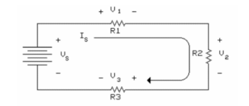

**Figure 2**

Using the adjustable D.C. power supply and the circuit bread board, connect the resistors

into a circuit. Note that the three resistors are in series so that the same current (Is) flows through each resistor. Let R1 = 1.5 kΩ, R2 = 820 Ω, and R3 = 2.2 kΩ.

|  |  |  |  |
| --- | --- | --- | --- |
|  | Color | Nominal | Actual |
| R1 | Brown-green-red-gold | 1.5k | 1.5k |
| R2 | Grey-red-brown-gold | 820 | 0.807 |
| R3 | Red-red-red-gold | 2.2k | 2.2k |

**Table 3**

|  |  |  |  |
| --- | --- | --- | --- |
| Value | Calculated | Measured | Differences |
| Is | 3.3mA | 3.5mA | 5.882% |
| V1 | 5.3V | 5.25V | 0.948% |
| V2 | 2.8V | 2870mV | 2.469% |
| V3 | 7.8V | 7.7V | 1.290% |

**Table 4**

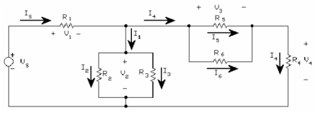

**Figure 3**

**Table 5**

|  |  |  |  |
| --- | --- | --- | --- |
|  | Color | Nominal | Actual |
| R1 | Brown-red-red | 1.2k | 1.17k |
| R2 | Orange-orange-red | 3.3k | 3.2k |
| R3 | Orange-orange-red | 3.3k | 3.2k |
| R4 | Red-violet-red | 2.7k | 2.6k |
| R5 | Green-blue-red | 5.6k | 5.5k |
| R6 | Yellow-violet-red | 4.7k | 4.6k |

**Table 6**

|  |  |  |  |
| --- | --- | --- | --- |
| Value | Calculated | Measured | Differences |
| I2 | 8.144mA | 8.1mA | 0.17% |
| V1 | 9.773V | 9.79V | 0.20% |
| V2 | 10.23V | 13.5V | 31.64% |
| V3 | 10.23V | 13.5V | 31.64% |
| V4 | 5.24V | 5.5V | 5.33% |
| I1 | 12.12mA | 16.7mA | 27.3% |
| I2 | 6.061mA | 4.08mA | 32.7% |
| I3 | 6.061mA | 4.08mA | 32.7% |
| I4 | 7.407mA | 7.068mA | 4.5% |
| I5 | 2.181mA | 2.216mA | 1.6% |
| I6 | 2.508mA | 2.57mA | 2.59% |

**Apply node voltage:**

Node 1: (v1-20)/R1 +v1/(R2//R3)+v1/(R5//R6+R4) = 0

=> V = 9.158V

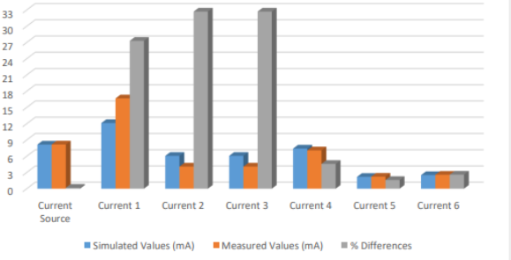

**Figure 4**

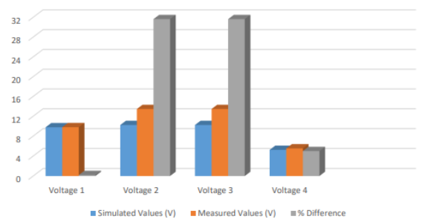

**Figure 5**

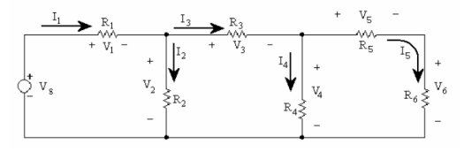

**Figure 6**

**Table 7**

|  |  |  |  |
| --- | --- | --- | --- |
|  | Color | Nominal | Actual |
| R1 | Brown-red-red | 1.2k | 1.18k |
| R2 | Green-blue-red | 5.6k | 5.58k |
| R3 | Orange-orange-red | 3.3k | 3.25k |
| R4 | Yellow-violet-red | 4.7k | 4.66k |
| R5 | Red-violet-red | 2.7k | 2.68k |
| R6 | Brown-red-red | 1.2k | 1.15k |

|  |  |  |  |
| --- | --- | --- | --- |
| Value | Calculated | Measured | Differences |
| V1 | 6.048V | 8.196V | 26.2% |
| V2 | 13.95V | 7.455V | 5.68% |
| V3 | 8.467V | 4.345V | 3.80% |
| V4 | 5.485V | 5.13V | 6.47% |
| V5 | 3.786V | 3.599V | 4.95% |
| V6 | 1.699V | 1.55V | 8.29% |
| I1 | 5.054mA | 4.569mA | 9.6% |
| I2 | 3.571mA | 3.369mA | 6.01% |
| I3 | 3.682mA | 3.535mA | 3.98% |
| I4 | 4.255mA | 3.948mA | 7.21% |
| I5 | 16.67mA | 16.223mA | 2.68% |

**Apply the mesh current**

Loop 1: -20+1200i1+5600(i1-i2) = 0

Loop 2: 5600(i2-i1)+3300i2+4700(i2-i3) = 0

Loop 3: 4700(i3-i2)+i3(2700+1200) = 0

=> i1=5.054mA

=> i2=2.57mA

=> i3=1.4mA

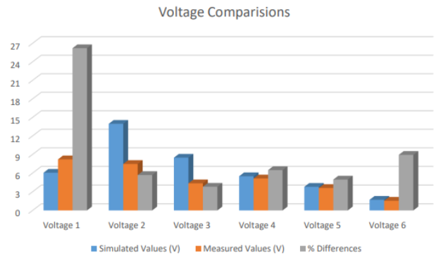**Figure 7**

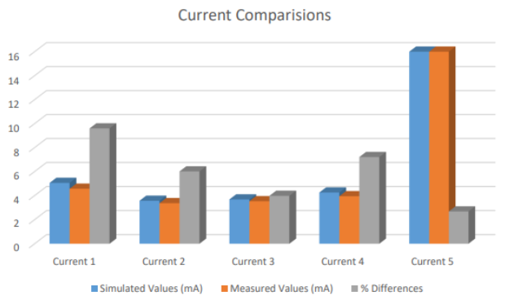

**Figure 8**

**Experimental Results**

In this section, describe the results. Remember to refer your reader to specific Figures, Tables and Appendices where applicable and show your calculations and data manipulation. Note that it is preferable to have Figures and Tables close to the text where they are discussed. The goal here is to report the results – ***NOT*** to discuss whether they are good or bad results. Usually the trends in a graph are pointed out, but not fully explained. The discussion of the trend is saved for the Discussion section.

**Discussion of Results**

**Section 1A:** The precision of our measurements underscores the success of the experimental setup. While there may be slight deviations, these can be attributed to factors such as resistor tolerances, subtle variations in experimental conditions, or inherent limitations in the measurement apparatus.

**Section 1B:** The measured values of current and voltage in the series circuit, with resistors R1 = 1.5 kΩ, R2 = 820 Ω, and R3 = 2.2 kΩ, closely mirror the calculated values, showing a range of differences between 2.838% to 3.930%. This consistency validates the application of Kirchhoff’s Voltage Law (KVL) in explaining voltage distribution within the series configuration. Minor variations within this range can be attributed to practical factors like wire resistances and measurement limitations.

**Section 1C:** We can conclude that with a parallel resistor, there are the same % differences of measured values on current and voltage. Otherwise, with the first try, we make mistake on setting Output voltage (not the directly 16V), so they seem to be a large error on this section.

**Section 2:** After performing calculations and comparing them to the actual values, it is evident that there is a noticeable increase in the errors of the figures. It is acknowledged that the pace at which we worked on this lab segment was slow, particularly when attempting to identify resistors based on the provided table.